# Chapter 1

## INTRODUCTION

* 1. **A brief introduction**

The revolution of computer in the past decades, have unfolded the use of computers, be it any field. The era of maintaining huge records for data storage has evolved. Computers have become most used tool in almost each field. It has made the life of humans easier. Also, computers have made research very easier. These huge records nowadays can be easily stored and uploaded to web for further access by various users throughout the world. One of the main tasks to be done in this project is that maintain a database which will store the number of songs of different genre and will be accessed using web on a particular site created. These advances in computer networking, combined with powerful home computers and modern operating systems, made streaming media practical and affordable for ordinary consumers. Stand-alone Internet radio devices emerged to offer listeners a no-computer option for listening to audio streams. These audio streaming services have become increasingly popular over recent years. By taking advantage of this, we are able to create an online music player which is easily accessible to anyone having internet. Also, it is user friendly as it is easy to navigate through and explore

**1.2 Problem Statement**

In general, multimedia content has a large volume, so media storage and transmission costs are still significant. To offset this somewhat, media are generally compressed for both storage and streaming. In order to reduce the storage space required, online streaming of music has proved to be more efficient. Since internet is very affordable now-a-days, people prefer to listen to songs online rather than downloading it and saving the file in a particular location and listening.

**1.3 Objectives**

The main objective of this project is to allow user to go through different songs of different genre online. These videos are basically stored in the database and is directly connected to web. This project will also help user to download the songs upon subscription, create their own playlist, search for their favorite artists and albums, and also find out the musical events happening around.

# Chapter 2

## LITERATURE SURVEY

This explains about the similar projects like Music Player. There are two projects similar to this:

1. Hackaday (https://hackaday.io)

This is a website that gives many useful options like events and trending music news, publications, about artists and description of the works and many others options. There are many advantages and disadvantages of using this website like:

Advantages:

* It provides better media options.
* It provides information on a broader basis.
* It also has the feature of knowing about the artist and his background.
* It also gives video links about the gallery.
* It also gives information about artists and their songs.
* Easy to use interface.

Disadvantages:

* The main disadvantage is that it doesn’t cover about current events happening around us.
* It has information regarding only few artists whereas the songs are huge n number.
* It has only the songs and no options of albums or genre.

2. Final media player (https://www.finalmediaplayer.com)

This is a media player software for the public. The advantages and disadvantages of this website are:

Advantages:

* It has an easy option for usage.

* Interesting GUI.
* Much options for songs and albums.
* Simple and easy to use, minimalist user interface.

Disadvantages:

* This website needs to be downloaded for usage.
* Only the first one month is free. Later, the website charges the people with specific amount of money based on the features that the customers wants.

## 

## Chapter 3

## SYSTEM REQUIREMENTS

## 

### Software Requirements

|  |  |  |
| --- | --- | --- |
| * Web server | : | XAMPP Server |
| * Back end | : | MYSQL |
| * Server side scripting | : | PHP |
| * Client side scripting | : | HTML, Java Script |

## 

## Chapter 4

## METHODOLOGY



*Fig 4.1: workflow of the project*

The above figure explains the complete workflow of the project how a user searches for the song online which will be retrieved from the web. How their details will be eventually stored in the database and they can surf easily.

Initially the user will have to create an account in the website to make use of the services. This will be completely free of cost. Once the account is created, the user is free to listen to any number of songs and make use of the platform to his best. The platform is user friendly. There are multiple artists and albums that the user can choose from. There is also an option to logout of the account once the usage is completed. Since this is completely free of cost i.e., there are no charges applied on the usage. Few songs are also stored in the database which can be searched upon. On receiving a request from the user, the database will be searched for the song and will be returned if found. With the help of internet this platform can be accessible anywhere.

# Chapter 5

# IMPLEMENTATION

### 5.1 HTML5

HTML5 is a markup language used for structuring and presenting content on the World Wide Web. It is the fifth and current major version of the HTML standard. It was published in October 2014 by the World Wide Web Consortium (W3C) to improve the language with support for the latest multimedia, while keeping it both easily readable by humans and consistently understood by computers and devices such as web browsers, parsers, etc. HTML5 is intended to subsume not only HTML 4, but also XHTML 1 and DOM Level 2 HTML.

HTML5 includes detailed processing models to encourage more interoperable implementations; it extends, improves and rationalizes the markup available for documents, and introduces markup and application programming interfaces (APIs) for complex web applications. For the same reasons, HTML5 is also a candidate for cross-platform mobile applications, because it includes features designed with low-powered devices in mind. Many new syntactic features are included. To natively include and handle multimedia and graphical content,new <video>, <audio> and <canvas>elements were added, and support for scalable vector graphics (SVG) content and MathML for mathematical formulas. To enrich the semantic content of documents, new page structure elements such as <main>, <section>, <article>, <header>, <footer>, <aside>, <nav> and <figure>, are added. New attributes are introduced, some elements and attributes have been removed, and others such as <a>, <cite> and <menu> have been changed, redefined or standardized.

The APIs and Document Object Model (DOM) are now fundamental parts of the HTML5 specification and HTML5 also better defines the processing for any invalid documents.

### 5.2 JavaScript and JQUERY

JavaScript often abbreviated as **JS**, is a high-level, dynamic, weakly typed, prototype-based, multi-paradigm, and interpreted programming language. Alongside HTML and CSS, JavaScript is one of the three core technologies of World Wide Web content production. It is used to make webpages interactive and provide online programs, including video games. The majority of websites employ it, and all modern web browsers support it without the need for plug-ins by means of a built-in JavaScript engine. Each of the many JavaScript engines represent a different implementation of JavaScript, all based on the ECMAScript specification, with some engines not supporting the spec fully, and with many engines supporting additional features beyond ECMA.

As a multi-paradigm language, JavaScript supports event-driven, functional, and imperative (including object-oriented and prototype-based) programming styles. It has an API for working with text, arrays, dates, regular expressions, and basic manipulation of the DOM, but the language itself does not include any I/O, such as networking, storage, or graphics facilities, relying for these upon the host environment in which it is embedded.

Initially only implemented client-side in web browsers, JavaScript engines are now embedded in many other types of host software, including server-side in web servers and databases, and in non-web programs such as word processors and PDF software, and in runtime environments that make JavaScript available for writing mobile and desktop applications, including desktop widgets.

jQuery is a fast, small, and feature-rich JavaScript library. It makes things like HTML document traversal and manipulation, event handling, animation, and Ajax much simpler with an easy-to-use API that works across a multitude of browsers. With a combination of versatility and extensibility, jQuery has changed the way that millions of people write JavaScript.

### 5.3 SQL (Structured Query Language)

**SQL** (**Structured Query Language**) is a domain-specific language used in programming and designed for managing data held in a relational database management system (RDBMS), or for stream processing in a relational data stream management system (RDSMS). In comparison to older read/write APIs like ISAM or VSAM, SQL offers two main advantages: first, it introduced the concept of accessing many records with one single command; and second, it eliminates the need to specify how to reach a record, e.g. with or without an index.

Originally based upon relational algebra and tuple relational calculus, SQL consists of a data definition language, data manipulation language, and data control language. The scope of SQL includes data insert, query, update and delete, schema creation and modification, and data access control. Although SQL is often described as, and to a great extent is, a declarative language (4GL), it also includes procedural elements.

SQL was one of the first commercial languages for Edgar F Codd's relational model, as described in his influential 1970 paper, "A Relational Model of Data for Large Shared Data Banks".[[10]](https://en.wikipedia.org/wiki/SQL#cite_note-codd-relational-model-10) Despite not entirely adhering to the relational model as described by Codd, it became the most widely used database language.

SQL became a standard of the American National Standards Institute (ANSI) in 1986 and of the International Organization for Standardization (ISO) in 1987. Since then, the standard has been revised to include a larger set of features. Despite the existence of such standards, most SQL code is not completely portable among different database systems without adjustments.

# 5.4 PHP

The past five years have been fantastic in terms of the explosive growth of the Internet and the new ways in which people are able to communicate with one another. Spearheading this phenomenon has been the World Wide Web (WWW),with thousands of new sites being launched daily and consumers being consistently offered numerous outstanding services via this new communications medium. With this exploding market has come a great need for new technologies and developers to learn these technologies. Chances are that if you are reading this paragraph, you are one of these Web developers or are soon to become one. Then you’ve heard of the great new technology called PHP.

**Characteristics of PHP:**

As you may have realized, the PHP language revolves around the central theme of practicality. PHP is about providing the programmer with the necessary tools to get the job done in a quick and efficient fashion.

Five important characteristics make PHP’s practical nature possible:

* Familiarity
* Simplicity
* Security
* Flexibility
* Efficiency
* It is free (so it makes interesting)

**PHP myadmin**

Also supplied by most hosting services is phpMyAdmin (you can also install it anywhere you want, as it's open source and free). This tool will allow you to view all the MySQL database, tables, and entries, as well as perform SQL queries remotely through a web browser.

Although we will be teaching how to create databases, tables and all other MySQL tasks through PHP, we encourage you to learn about phpMyAdmin. It’s easy-to-use interface will allow you to do many common MySQL tasks quickly and easily.

## 

# Chapter 6

## SNAPSHOTS

### 6.1 The Login Page

This is the initial page that greets a visitor. A user can enter their login details, or they can sign up, which will take them to another page.

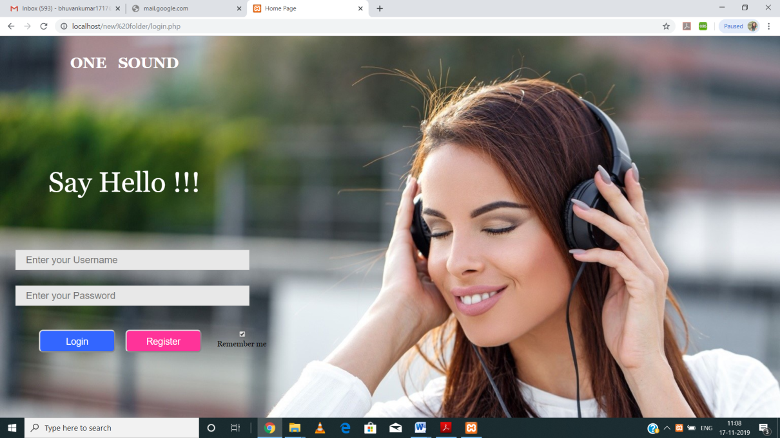

*Fig 6.1 Login Page*

### 6.2 The Register Page

Here, a user can enter their details to sign up for the Music website.

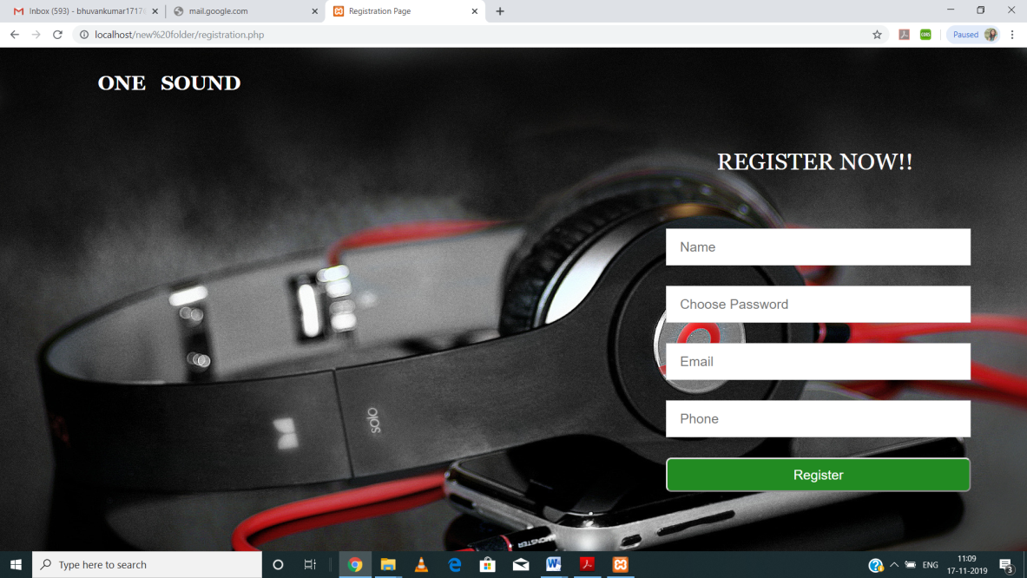

*Fig 6.2 Sign Up Page*

### 6.3 The Home Page

The Home page is the initial page where all the user’s personal files will be displayed. Images are displayed in a different fashion.

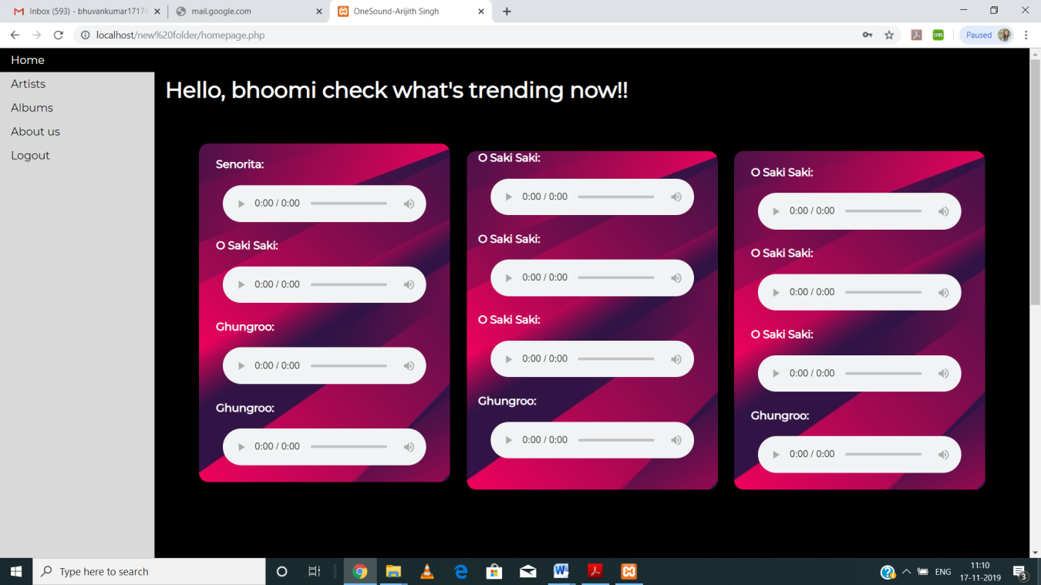

*Fig 6.3 Home Page*

### 6.4 About us (in Home Page)

It provides informaion about the website.

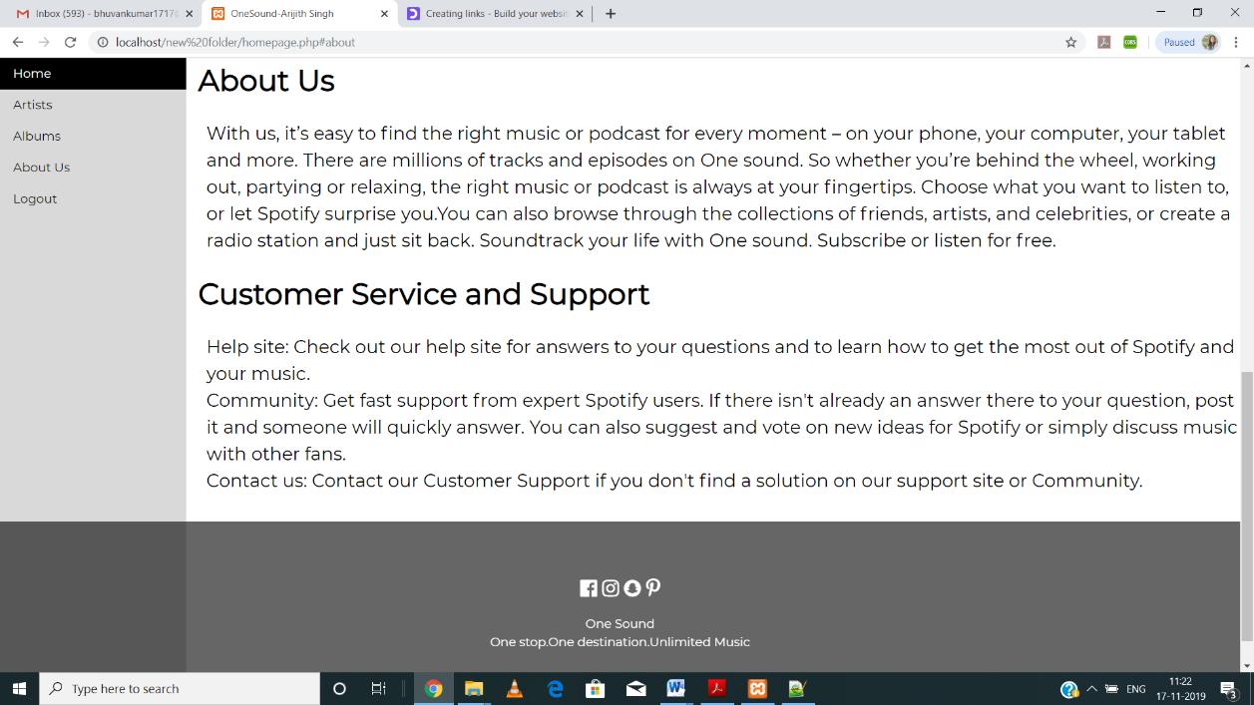

*Fig 6.4 About us*

### 6.5 Discover Page

The first screen for the website is discover page.

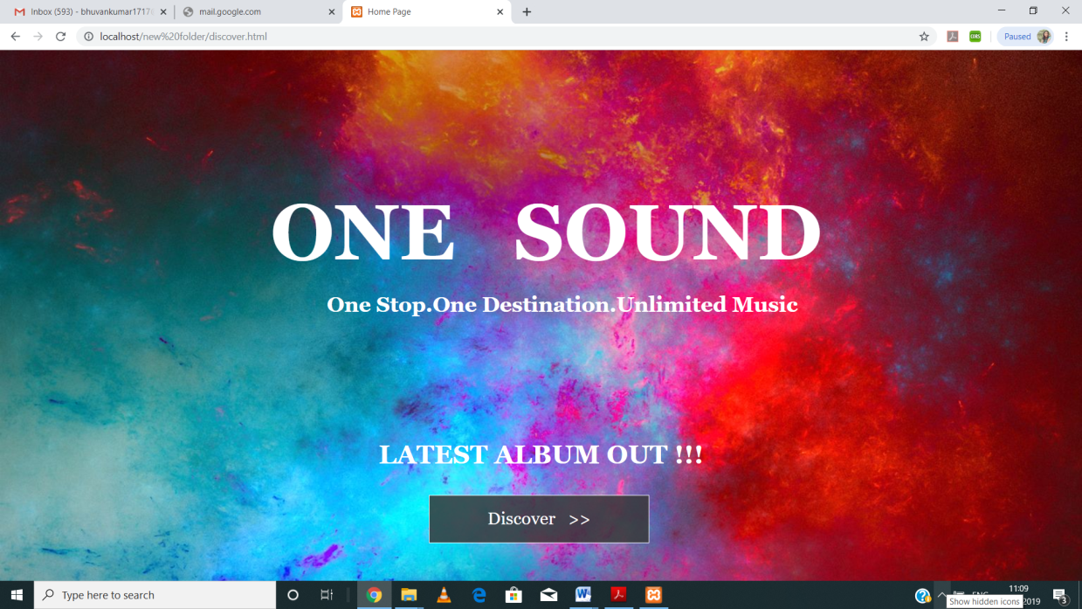

*Fig 6.5 Discover Page*

#### 6.6 Albums Page

In this page user can select album and listen to songs of those albums.

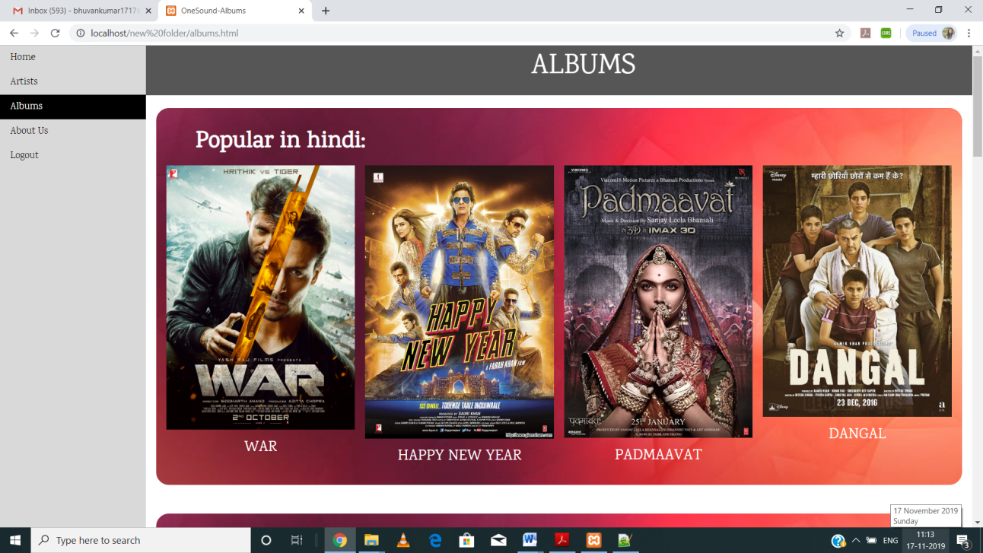

*Fig 6.6 Albums Page*

### 

### 6.7 Player Page

This page helps the user to perform actions on the song.

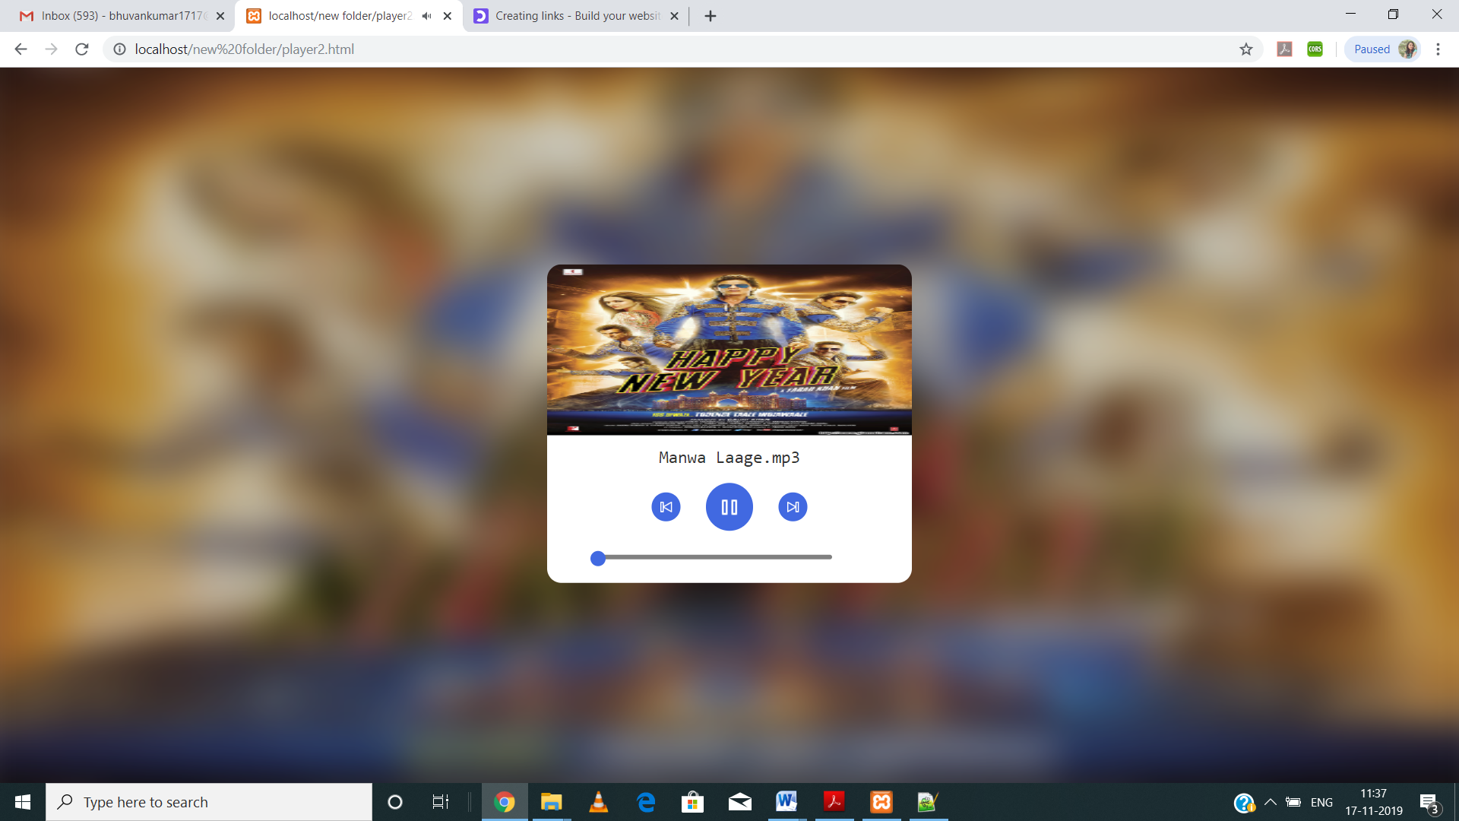

*Fig 6.7 Player page*

### 6.8 Artists Page

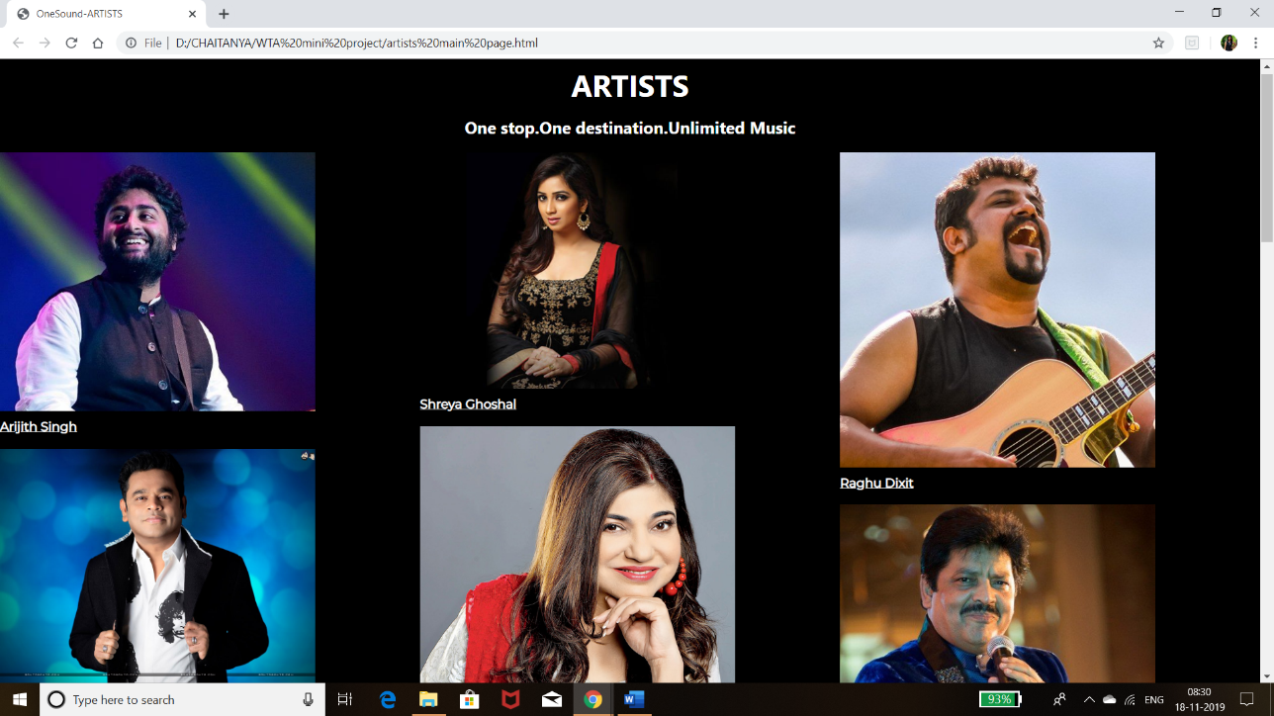

*Fig 6.8 Artists Page*

### 6.9 Tables

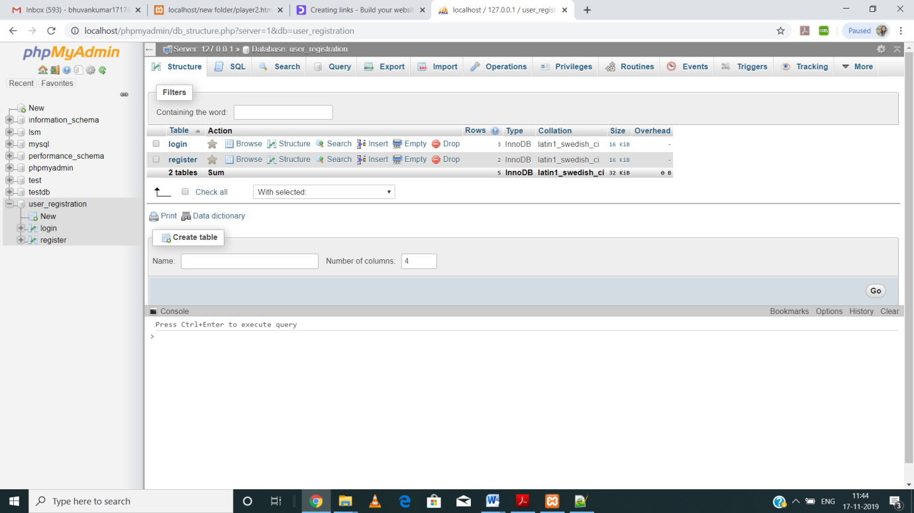

*Table 6‑1 All Table Details*

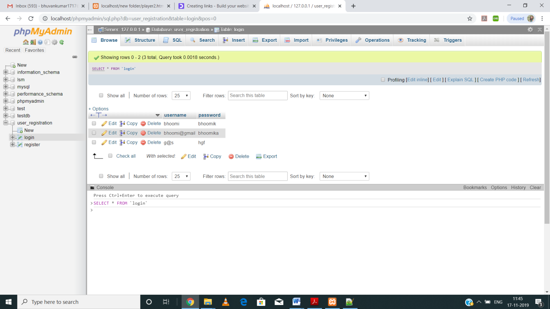

*Table 6‑2 LoginTable*

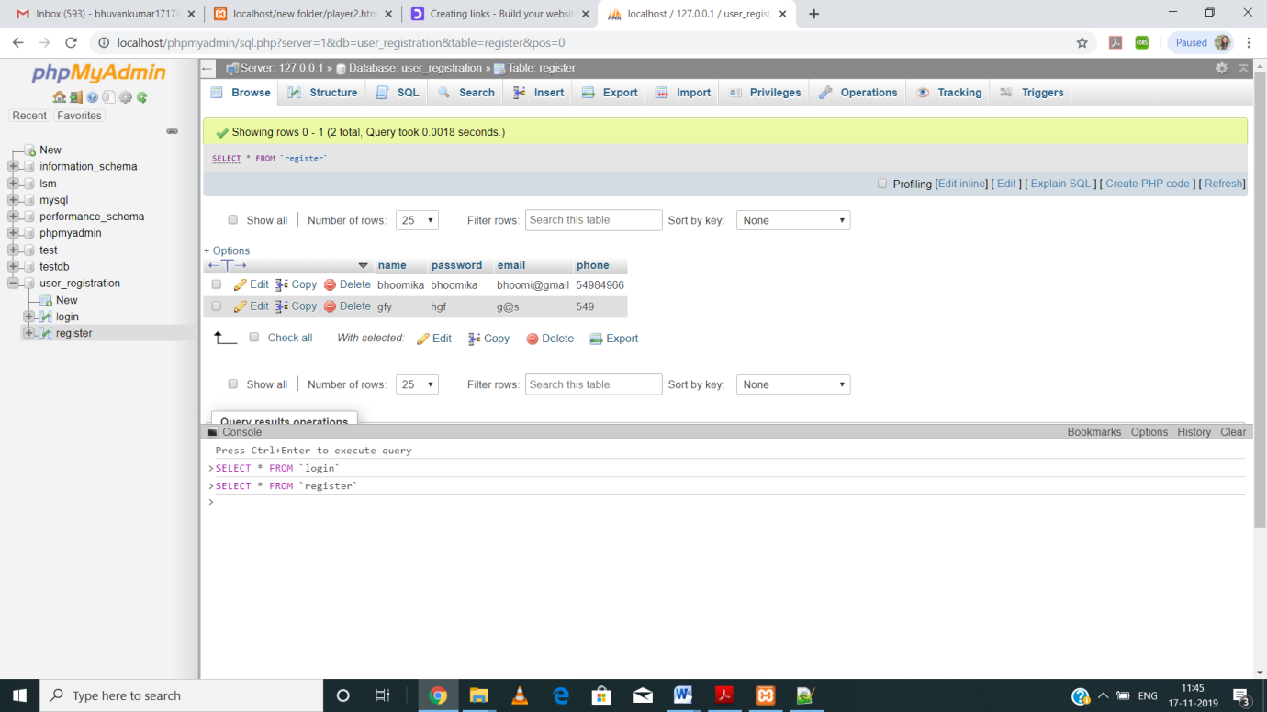

*Table 6‑3 Register Table*

**CONCLUSION & FUTURE ENHANCEMENT**

After seeing the increase demand of audio music apps for the different genre and the artists. We land on a conclusion that this project will be helpful for the users with a great love for music of different genre. The technologies like phpmyadmin which is a SQL database is used to store the database and will make easy to create the server for the working of the project.

This project is an attempt to make the structure and working of any online music player simpler and user-friendly. In this scenario, all the undertakings of a Music player are achieved in a constructive manner. Given the right guidance and support, we hope to enhance its applications and availability.

The Future enhancements:

* Allowing users to download songs.
* Advanced software for music player including more facilities like latest videos and musical events happening around.
* Hosting the platform on online servers.
* Create the master and slave database structure to reduce the overload of the database queries.
* Implement the backup mechanism for taking backup of codebase and database on regular basis on different servers.

**REFERENCES**

• W3Schools (HTML, CSS, JQUERY & PHP reference) – https://www.w3schools.com

• PHP Official Documentation – http://php.net/docs.php

• The MySQL Documentation – https://dev.mysql.com/doc

• Stack Overflow – https://stackoverflow.com

• Wikipedia – https://www.wikipedia.org